Heat of Formation Group Performance Assessment

Assessment:

Task: Calculate the heat of formation for magnesium oxide.

Information & Tips
The heat of formation of liquid water is -285.8 kJ/mol.
The average calorimeter constant for this set-up has been determined to be 5.6 J/ºC.
The specific heat of the reaction mixture is 3.75 J/gºC
You will be provided with the following materials:
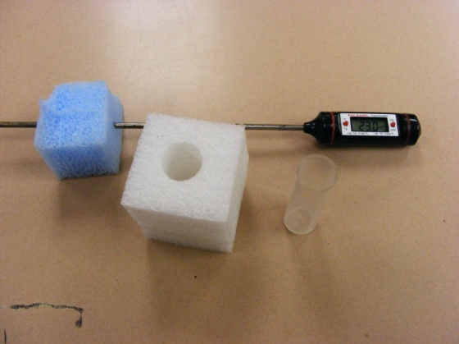
1. 1.5 cm of Mg ribbon [the mass in grams per meter will be given on the board--be sure to record it!]
2. 2.0 M HCl (use about 8 mL each time)
3. a calorimeter, lid
4. MgO (use about 0.5 g)
5. a thermometer probe
Transfer errors
In calculating the heat released by the reactions it is important to know the mass of the reaction mixture. Because we are using small amounts in this experiment we need to try and minimize the error that would normally not be very significant when, for example, liquid is added from a graduated cylinder.
In the “Specific Heat of an Unknown Metal” experiment you used a technique of massing the amount of liquid added to a reaction by the difference of the graduated cylinder full of the liquid and the cylinder after the liquid had been poured out. That would be appropriate in this experiment once again.
The MgO is a very light powder and tends to stick to glass to some extent, so it too is a problem if you plan on measuring some into a beaker and dumping it into the calorimeter. You could mass by difference but there is the additional problem of adding the powder to a calorimeter full of HCl. The reaction begins immediately at the surface and heat is lost (spray too) before the lid is replaced. One way to reduce this error is to measure the MgO directly into the calorimeter and then add the HCl quickly.
Drying the calorimeter
For this to work it is important that the calorimeter is dry. It is important that the insides of the calorimeter tubes are completely clean and dry before each experimental trial. Drying the inside with our normal paper toweling requires a gentle touch.
Dealing with the thermometer probe and even heating of the solution
In order to allow for uniform heating of the mixture in the calorimeter, you will need to maintain a gentle swirling of the apparatus as the reaction proceeds.
After completing the lab portion of the assessment:
Dump waste in the waste container and rinse well.
Do not dispose of excess chemicals in the drain.
Leave lab station in proper order

Perform calculations at your seat
Show all work and circle final answer
Answer “Additional Questions:
- Most Mg ribbon is uniform enough that the mass of a small measured length is proportional to the mass of a larger measured length. Assume that the mass of 1.00 meter of Mg ribbon is 0.4368 g. Show that using 3.0 cm of this ribbon and 15 mL of 2.0 M HCl makes Mg the limiting reagent in the reaction between the two substances.
- Show how the following three reactions actually add up to give the formation reaction for MgO (Reaction 4)
Mg(s) + 2 HCl(aq) → MgCl₂(aq) + H₂(g) (1)
MgO(s) + 2 HCl(aq) → MgCl₂(aq) + H₂O(ℓ) (2)
H₂(g) + ½ O₂(g) → H₂O(ℓ) (3)
- With the final result the question arises as to its accuracy. Use the following calculated values for ΔH to assess you accuracy.
Reaction (1) -462 kJ/mol Mg
Reaction (2) -146 kJ/mol MgO
Reaction (4) -602 kJ/mol MgO
For each, determine the percent in your experimental results and briefly discuss any significant deviations with specific reference to things you did and would not do again, etc.

Turn in performance assessment and pick up multiple choice portion of the assessment.

Reflection/Teaching Tips:

Purpose for the assessment:

This assessment is used to assess problem-solving as well as Hess’ law concepts.

Possible ways to use the assessment:

It can be used more at the end of the unit – after students had practiced the concept a few times and could think through the process. It would be a multi-day task.

